Operational Management Team Meeting - 11 November 2022 (13.30-15.30 CET)
Document File Name | OMT_Minutes of Meeting_20221111
Date – Place & Time | 11 November 2022/ Videoconference: 13.30-15.30 (CET)
Minutes | Shamim Patel
Dial In Link | Zoom link as advised by calendar invitation

Attendance:

Operational Management Team Members | Present | Excused
Marcelo MILRAD (Coordinator WP1 / WP4 & LNU) | x
Sofia PAPAVLASOPOULOU (WP2 & NTNU) | x
Christothea HERODOTOU (WP3 / WP8 & OU) | x
Chronis KYNIGOS (WP5 & NKUA) | x
Lieva VAN LANGENHOVE (WP6 & UGent) | x
Carina GIRVAN (WP7 & TCD) | x

Guests | Present | Excused
Filothei CHALVATZA (SIMPLE) – Permanent Guest |  | x
Marianthi GRIZIOT (NKUA) – Permanent Guest | x
Manolis MAVRIKIS (UCL) – Permanent Guest | x
Katrien STRUBBE (UGent) – Permanent Guest |  | x
Shamim PATEL (LNU) - Project Manager | x
Minutes of Meeting (draft)

Folder for all meeting related documents:
https://drive.google.com/drive/folders/1M2g5RSIyhdSMn9LpyOgsCqBOqcm5Hhjy?usp=sharing

OMT: 2022-11-11-001 | Welcome, Approval of Minutes from OMT Meeting 10 October 2022; Approval of Agenda (MM)  - The minutes of the OMT meeting from 10 October 2022 were approved.  - The agenda was approved.  - The meeting was quorate. It was noted that MaM (UCL) would additionally represent SIMPLE whom apologies were received from.
OMT: 2022-11-11-002 | Updates from EC (MM/SP)  Information:  - After the October OMT meeting LNU had a zoom meeting with the Project Officer (PO). Discussions and follow up email correspondence are summarised below.  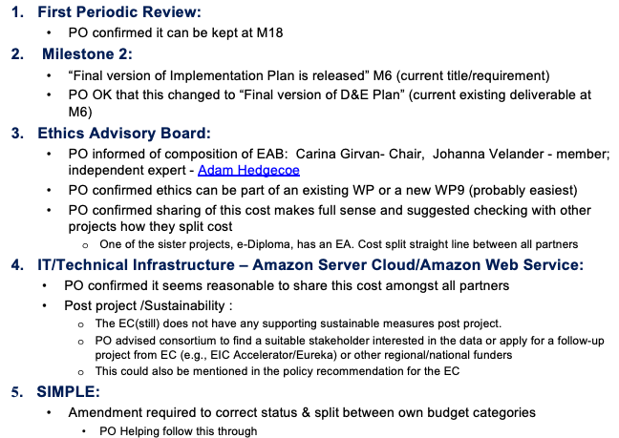
OMT: 2022-11-11-003 | Updates from WP2-WP8: (WP Leaders)  - WP1-WP8 Meetings: Noted some WPs plan to have meetings regularly, other WPs on a “need to” basis.  Action: SP to set up /share a calendar in the Project Drive where WP Leaders can update their planned WP meetings. When: before next OMT meeting.  Information:  Presentations from each WP on their updates below can be found here and are also linked below.  WP2: A light/rapid review or a full systematic review? A first screening of papers has been done. 180 need further analysis. See linked slides for further details for criteria, search strategy, methodology, inclusion, exterior criteria, and preliminary results from the first screening of papers.  Thematic reviews in connection with our Project - and where it was positioning itself in relation to other studies were further suggested for consideration. Two further sources were shared: Journal of Science Education and Technology and ICTMT 16.  Action: Future WP2 meetings (planned ca. every two weeks with relevant representatives from each WP) will discuss the strategy further and follow up steps (choosing relevant papers – which ones to include/exclude, missing papers, defining classification criteria, and drafting the M6 deliverable).  WP3: An internal co-production workshop (TCD, NKUA, UGent, OU) was held on 24 October 2022. A better understanding of what the term “co-production” for the project means has resulted. An “onboarding workshop”, with currently six new UK teachers, is planned on 30 November: 16.00-18.00 UK time. This will be similar to the 2 internal workshops already held. The target group is any new teachers. Teachers from other countries are welcome to join!  Re, Technical developments: Meetings with technical teams from SIMPLE, NKUA, UCL and OU have taken place and more are planned which will result in a new version of nQuire - which can be used by students and teachers (protected environment), and will have upload file functionality (either a new response type or URL sharing).  WP3 meetings will be held on “a need to” required basis.  Action: Following the co-production workshop CH to propose a co-produced structure to working with teachers in workshops based on discussions.  WP4: See linked slides for the data collection process and decisions following the technical meetings on integration of nQuire with the other learning tools: Re, T4.1 - the Extend.T.2 platform based on the SMILE platform - the nQuire Platform will be used by teachers and students for “missions” and there are plans for it to be adapted to overcome e.g., restrictions such as age in some circumstances. Re, T2.2 - the existing ChoiCo and SorBET - game applications with AR components will be extended; Re, T.4.4 - see slides for decisions on extending learning tools to capture and generate data for analysis including links for technical specifications, and LA high-level requirements.  A decision is underway to use Amazon Cloud Server and Services to host the Exten.D.T.2 platform. The server configuration (linked here) is designed together with SIMPLE, NKUA and LNU.  LNU is responsible for the server configuration and maintenance.  Action: See #006 below for further follow up on the Cloud Server.  WP5: The Design Thinking Activity Plan Template (linked here) needs further internal discussion and testing with the teachers as there was not enough time during the workshops. An aim is for teachers to codesign activities/activity plans with us.  A report on the First Workshop was presented. See linked WP5 slides for statistics, and presentations from teachers (green boxes) and project participants (blue boxes), and also “outcomes, issues and future plans” following the first workshop. Noted for example that some teachers are from different domains; some have experience in DT and technology, others do not.  Future work includes teacher co-design workshops per country (in collaboration with WP3); creating and sharing examples of activity plans; and creating & sharing teacher resources such as manuals - which may need to be translated.  It was suggested that it may be good to include a workflow tool within the template if possible. NTNU (Boban Vesin) and TCD asked to be invited to future WP5 technical meetings too, where applicable, for their work.  Action: Feedback welcome on the Design Thinking Activity Plan Template. A future meeting will also be organised in connection with this.  WP6: KS was not present. Per LvL, UGent needs feedback on what are the hurdles for teachers which are preventing them from using the co-design methodology.  WP7: See linked slides for updates and progress on co-production activities (need co-production design to be agreed before evaluation can be designed), systematic review (to look at existing instruments which will help measure 21C thinking) and setting up of the Ethics Advisory Board (EAB).  Action: A meeting will be held to cover what do we want to learn from the evaluation? (i) What is the overarching research question that drives this project? and (ii) What does each WP need from each evaluation cycle?  Feedback is already welcome on: https://wooclap.com/NZRBUO  WP8: A first version of project website is live for comments and amendments. A researcher has been recruited who will start working from 10 January 2023. A YouTube channel has been created where lectures, videos can be uploaded and shared. An extended subtract for EARLI conference was submitted on 27/10/22 (outcome pending) with all PI names included as co-authors. A first version of the Dissemination and Exploitation deliverable (M6) has been drafted and a separate meeting will be scheduled to discuss this further.  The WP8 folder, includes photos; the project logo; the invitation to teachers; an excel sheet to record any dissemination activities; a deliverable template for the project (feedback to CH welcome); and some slides put together by CH which can be used by everyone to present the project to teachers, etc.  Actions: (i) TCD, UCL, SIMPLE to send their institutional logos to CH asap.  (ii) Everyone to fill and update the excel spreadsheet on dissemination activities regularly (e.g., at the end of each month). A reminder will be sent by CH.  (iii) A separate meeting will be scheduled by CH in due course to discuss dissemination activities and the D&E Plan further.
OMT: 2022-11-11-004 | Ethics Advisor/Ethics Advisory Board: (MMSP)  Information:  The background information plus proposal of related work & costs had been shared with the partners pre-meeting. See link above. There were no further questions. Various options were presented for transparency and the coordinators choice (Option 4) and reasoning presented.  DECISION: Option 4 was accepted as the principle on which to base apportionment of costs by all partners with no objections:  LNU, NKUA, UGent, NTNU and OU will split the costs currently estimated at €990 each. The cost will be shared between all organisations except TCD (for the reasons provided in the background documentation) and SIMPLE who as an SME has the smallest budget and for example, less infrastructure or overheads to absorb these additional costs.  Practicalities would be reviewed at a later stage.  - Noted at this meeting that the Ethics Advisor (EA) would need to send at least two invoices – one to OU who is funded by UKRI and one to LNU as coordinator on behalf of all partners receiving EU funding. Alternatively invoices to each partner for their respective share may be sent by the EA.  - For Partners receiving EU funding: in the case where the EA sent an invoice to LNU only, these partners would then likely have their funding reduced /transferred to LNU by the applicable amount (990 EUR) at the next EU payment.  Requested Information:  - Partners may decide themselves where they wish to reduce their budget to cover these costs, i.e., from personnel, travel, equipment or other goods and services.  - This is in line with the Section 5.5 of the Grant Agreement which allows for budget flexibility:  “The budget breakdown may be adjusted — without an amendment (see Article 39) — by transfers (between participants and budget categories), as long as this does not imply any substantive or important change to the description of the action in Annex 1.
OMT: 2022-11-11-005 | IT Infrastructure: (MM/SP)  Information:  - The background plus proposal of specifications related work & costs, as linked above, had been shared with the partners pre-meeting.  - Noted that the cost based on 36 months was likely to be less than 4 500 € as we were already in M3 of the project.  - Various options for splitting the cost were included for transparency. LNU’s proposal (option 4) was on the basis that LNU additionally contributed to significant in-kind work and services from its IT department in relation to this infrastructure. Noted that OU, NKUA, UGent, SIMPLE and other partners would also contribute with related infrastructure in-kind work and services.  - A new proposal presented at the meeting was that the eventual cost should be split on PM in the project budget.  DECISION:  The newly proposed option during the meeting , i.e., splitting the cost between each partner receiving funding (i.e., excluding UCL) based on their funded PMs in the signed Grant Agreement at the project start was accepted by all partners.  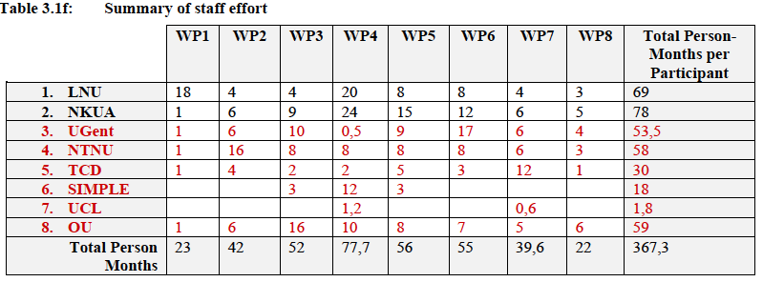  Based on the signed GA (see extracted table above) this would be the following % of the cost:  LNU (18.9%); NKUA (21.3%); UGent (14.6%); NTNU (15.9%); TCD (8.2%); SIMPLE (4.9%) and OU 16.1%).  - Practicalities based on eventual cost would be dealt with later but likely to follow the same principle as #004 above.  Action: LNU to discuss further with TCD and UCL precise requirements and possible contacts/suppliers who can supply the required service for our Project at most favourable terms.
OMT: 2022-11-11-006 | Joint Data Controller Agreement  - A draft Joint Controller Agreement from LNU’s DPO has been shared as linked. Partners should forward this to the person responsible for data protection /governance in their organisation and also their legal department as the document is related to the Consortium Agreement.  - Information required from each Partner by Thursday 24 November:  - Feedback / request for any changes  - Organisation policy regarding GDPR  - Contact information regarding the signing of documents pertaining to GDPR. This may be different to the person who can sign the CA for each organisation.
OMT: 2022-11-11-007 | Webpage https://extendt2.eu (CH)  Information:  - OU has bought a package from a commercial company as it was not appropriate to include it as part of the OU “ac.uk” website, as the UK is not funded by Horizon Europe.  - The word press package does not have flexibility to cover analytics which are needed to report KPIs, so a new package may need to be bought (ca 25 USD a month).  - Sustainability post project was raised. A solution may be to transfer it onto a partner University server post project such as LNU or OU. Now that there is a domain this should not be an issue.  - The gmail address for queries extendt2@gmail.com on the website on the website is linked to the twitter account.  Suggestions for improvements/features/functionalities/templates of the interface were discussed.  - Websites of our sister/cluster projects were recommended to be reviewed.  DECISION: Agreed that templates could be based around the colours of the logo.
OMT: 2022-11-11-008 | Consortium Collaboration Tools: (SP)  Information  - Logo and Deliverable Template (CH): The logo has been discussed above. There is a deliverable template in the WP8 google drive folder. Feedback welcome.  - Shared Bibliography (CG): Zotero is being used and seems to be fine. Anyone can go into this, create a group, and invite others to join.  - Glossary: SP will create a google worksheet where everyone can provide input on definitions terms, etc. This can, when agreed, be shared on the webpage. Action: To be followed up at the next meeting.  - Google Drive Folder including WP folders (SP): If anyone does not have access, please send SP an email with their gmail address.  - WP leaders are responsible for the content of their own folder.  - Mailing Lists (SP): There have been a few issues with the two mailing lists (one for all researchers and one for the OMT members). Other options may need to be looked at if there continue to be recurring issues.
OMT: 2022-11-11-009 | Overview of Current Work (SP)  Information  - GANTT Chart:  - All WPs have now started. Noted the deliverable for WP2 in M6 was omitted in error in the GANNT chart submitted in the GA.  - Deliverables due up to M6, include the Project Handbook (due M3)  - SP has started work on this deliverable and will ask for input from various OMT members in the coming weeks.  - Feedback from all OMT members should suffice as a quality control for this deliverable.  - Quality Control:  - Suggested for future (research) related deliverables, a good routine would be for the Lead PI to firstly share a contents page (in good time before the deadline) and to have a spreadsheet for reviewers of each deliverable.  - Time would need to be factored in for reviewers to have sufficient time to provide review comments and for the authors to implement comments before the final version is submitted to the EC.  - Discussions focused on whether the Lead/Responsible PI for each deliverable should propose reviewers or reviewers should volunteer themselves. It was proposed that the Lead author should propose reviewers in the first instance.  - WP Leaders may also like to consider which deliverables are useful for them to read especially in relation to their work.  - The process will be described and included in the Project Handbook (D1.1).  Action: SP to set up and share the related spreadsheet on the google drive. When: Before the next OMT meeting in December.
OMT: 2022-11-11-010 | Scientific Board (CK)  Decision/Action:  CK to contact Barbara Wasson and Tilde Bekker and go through their remit with them as in the Grant Agreement, with copy to MM.  Noted: There is travel budget for each of them to attend two project related meetings each over the duration of the project but not their time.
OMT: 2022-11-11-011 | Next OMT Meeting & AOB  - Next OMT Meeting: 9 December 2022: 13.30-15.30 CET.  F2F Meeting (Athens, 29-31 March 2023)  - MG and CK will keep all up to date of any developments).  New WP9 description for the Ethics/EAB  Action: To be drafted by CT and SP before the December OMT meeting.  Expectations on Receiving Responses  - This was again discussed. A policy would be proposed in the handbook (Deliverable 1.1) including eventual Coordinator contact.  - This would be one of the first points on the following meeting’s agenda.  There being no other business the meeting was closed.

